[单击此处键入标题]
[单击此处键入作者姓名]
[单击此处键入作者单位名称,城市名,邮编]
摘 要：[单击此处键入摘要]
关键词：[单击此处键入3-5个关键词]
中图分类号：[单击此处键入中图分类号] 文献标识码：A 文章编号：
DOI：10.11999/JEIT××××××

[单击此处键入节标题1]
[单击此处键入正文]
[单击此处键入节标题1.1]
[单击此处键入正文]
[单击此处键入节标题1.1.1]
[单击此处键入正文]

常见问题说明：
题目与书写：(1) 论文题目，尽量避免“基于……”等使用频次过高、雷同的窠臼句式，英文题目同理；(2) 按照学报官网的“投稿须知”认真书写每部分内容 ，不规范的书写编辑部可直接退稿；(3) 全文使用单栏排版、单倍行距(约16 磅，长英文摘要Euclid字体直接使用16磅)，尤其注意图表制作要易于阅读、美观准确，直接影响论文能否顺利初审。

中图分类号可参考：（超链接，按Ctrl单击打开），有TN开头分类号的请优先给出

缩写：缩写首次出现时，要尽可能给出全称
（1）（中、英文）摘要中：中文全称(缩写)、英文全称(缩写)；（2）正文中：有中文名的：中文名称 (英文全称, 缩写)，没有中文名的：缩写 (英文全称)；（3）缩写对应在全称中的字母要大写：如 Quality of Service (QoS)，首次出现给全称后，下文可直接使用缩写。

多层内容标识：第1层用(1), (2), …；第2层用(a), (b), …；第3层用①, ②, …；第4层用(ⅰ), (ⅱ), …。

文献编号：若提供作者姓名，文献号要以上标的形式标注在人名上，如“Pan^{[6]}在……”；若不止1个作者，要加“等人”，如“Ji等人^{[7]}同时……”，“人”字不能少；若直接用文献号做主语，不用上标，平排即可，如“文献[8]提出……”。多个文献号，不连续的用半角逗号隔开，3个及以上连续的用“–”表示，如“文献[2,4–7,9]”；一处引用的所有文献号都写到一个括号内。

公式与变量：论文中所有参量和公式，简单的可直接用word给出，复杂的用MathType编辑，尺寸设为标准：
(1) 只有单字母变量用斜体，非变量及多字母表示的变量一律正体；
(2) 只有矢量和矩阵用粗体，单字母变量矩阵用粗斜体，集合也不例外；
(3) 变量的上下标格式要求同上，即当上下标为非变量时，用正体；
总结：矩阵/矢量用粗体，单字母变量用斜体，既是单字母变量，又是矩阵/矢量，用粗斜体
(4) 所有数值与单位间均要空1格（°、℃除外）；
(5) 为了排版美观，独立成行的公式中用并排，，在正文内一般平排,，前后有分式时并排；
(6) 本刊一般用“×”或 “· ”表示乘法运算，不用“*”（“*”一般表示卷积等运算，且要在式后说明；
(7) log的底需明确，不能空缺，若是以10为底的lg和以e为底的ln，直接用简写。

(1)

插图：本刊插图要求作者提供可编辑的矢量图，如emf, pdf, fig或eps, visio等格式文件，没有文字的位图提供600 dpi的图文件。常用统计软件做的图可直接提供源文件，例如excel, origin等。将所有插图源文件（命名含图号，且与文中一致）整合到一个独立的压缩包，上传稿件系统！本刊自2021年始改为全彩印（版面费统一500元/页）。
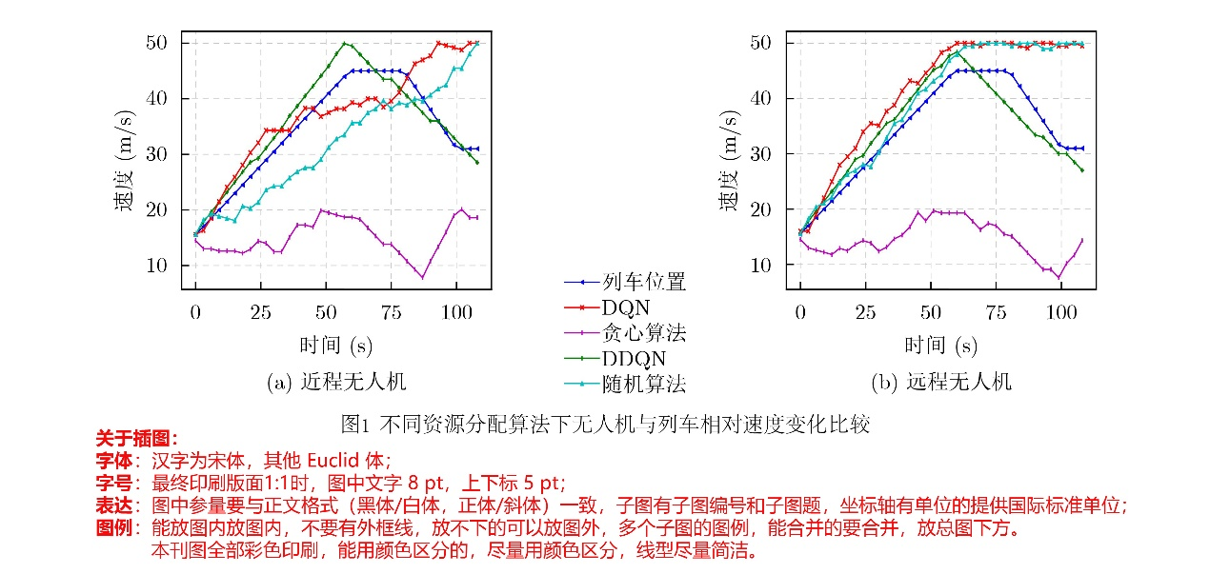
图具体规范：
(1) 插图线条：线粗为0.5磅(4 px)，中文用宋体、外文用Euclid，字号用8 pt；
(2) 图中≥2幅子图时，需给出对应子图题，且放到子图正下方，不要放到总图题中；
(3) 插图格式：能提供矢量图的请提供矢量图，只能提供遥感图像、照片等位图的，请尽量保证分辨率为600 ppi以上；每幅图按其出现的序号命名为图1、图2等，图号全篇统筹，不分章节。所有插图压缩成一个文件，并以稿号命名，如“220001图”，作为附件上传到投稿系统。

表格：本刊采用“三线表”的方式进行排版，如表1所示，表格布局要合理科学，一目了然。主要需要注意以下几点：
(1) 表格中同类参数数值若为小数，则小数点后有效位数应保持一致。
(2) 当表中单位相同时，只需在表题或首行首列标注即可。
表1 在SYSU-MM01的All-search模式单镜头设置下实验结果(%)
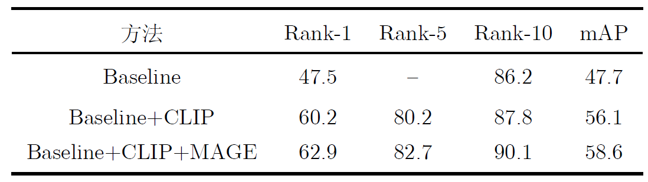
参 考 文 献
（文献引用如果要引用本刊以往文章，最多不宜超过2条；中文文献需给出对应英文，有doi信息请在尾处给出，会议论文要给出举办国家和城市，线上会议用[C/OL]表示，可以不给出举办地；文献中的国外作者，同样要姓前名后，姓全大写，名用缩写（大写首字母））
期刊类：
[作者1], [作者2], [作者3], 等. [题目][J].[刊名], [年] ,[卷] ([期]): [起止页码].doi: [doi号].
例如：邵延华, 张铎, 楚红雨, 等. 基于深度学习的YOLO目标检测综述[J]. 电子与信息学报, 2022, 44(10): 3697-3708. doi: 10.11999/JEIT210790.
SHAO Yanhua, ZHANG Duo, CHU Hongyu, et al. A Review of YOLO Object Detection Based on Deep Learning[J]. Journal of Electronics & Information Technology, 2022, 44(10): 3697-3708. doi: 10.11999/JEIT210790.
书籍专著类:
[(编)作者1],[(编)作者2],[(编)作者3], 等. [译者1], [译者2],[译者3], 等. [书名][M]. [版本], [出版地]: [出版社], [年份]: [起止页码].
例：张克潜, 李德杰. 微波与光电子学中的电磁理论[M]. 2版. 北京:电子工业出版社, 2001:15-18.
ZHANG Keqian and LI Dejie. Electromagnetic Theory for Microwaves and Optoelectronics[M]. 2nd ed. Beijing: Publishing House of Electronics Industry, 2001:15-18.
会议录类:
[作者1], [作者2], [作者3], 等. [题目][C], [会议名], [城市, 国家], [会议年份], [会议录卷号(如有)], [会议录起止页码(如有)].
例：YUAN Jian, ZHOU Xuesi, and HUANG Yongfeng. Application of HOOK technology in network covert communication[C]. The 9th China Information Hiding Workshop, Chengdu, China, 2010: 489-496.
学位论文类:
[作者]. [题目][D], [[博士论文/硕士论文]], [学校或研究机构名称], [年].
例如：刘光平. 超宽带SAR高效成像算法研究[D]. [博士论文]. 国防科技技术大学, 2003.
注：硕士论文/Master dissertation，博士论文/Ph. D. dissertation，学位论文也要提供英文对应信息
专利类:
[作者1], [作者2], 等. [题目][P]. [国别], [专利号], [年].
例：刘加林, 多功能一致性压舌板[P].中国, 922149852,1993-04-14.
报告类:
[作者/机构名称]. [题目][R]. [地址], [年份].
例：World Health Organization. Factors regulating the immune response[R]. Report of WHO Scientific Group, Geneva: WHO, 1970.
网络资源类:
[作者]. [题目][OL]. [网址], [下载日期].
例：Floyd S. RED: Discussions of setting parameters [OL]. http://www.cciri.ora/floyed/REDparameters.txt. 1997.5.
技术标准类:
[作者/机构名称].[标准代号/顺序号-发布年标准名称][S]. [出版地], [出版者], [出版年].
例： IEEE 802.11-1997. Wireless LAN Medium Access Control (MAC) and Physical Layer (PHY) Specification[S]. 1997.
作者简介部分
[作者1]：[性别]，[职称]，研究方向为[研究方向].
[作者2]：[性别]，[职称]，研究方向为[研究方向].
[单击此处键入英文标题]
[单击此处键入作者姓名拼音]
姓前名后，姓氏全大写，名仅首字母大写
[单击此处键入作者单位英文名称, 城市名 邮编, 国家]

Abstract:
Objective [单击此处键入摘要]
Methods [单击此处键入摘要]
Results and Discussions [单击此处键入摘要]
Conclusions [单击此处键入摘要]
Key words: [单击此处键入3-5个关键词]

《电子与信息学报》“英文长摘要”格式要求
- 篇幅：英文长摘要篇幅要求在800~1200字（单词数）。
- 结构：
  - 题目、作者和单位：与中文信息对应；
  - 英文长摘要正文：
    - 研究目的(Objective) :（突出所做工作的重要性和必要性）；
    - 研究方法(Methods)；
    - 创新性结果(Results and Discussions)：请标示出文字内容对应图表编号，以括号标注。如“…(Fig.1), …(Table 2), …(Algorithm 1)”等，括号内容不作为句子成分(删除与否，不影响表达)；
    - 结论(Conclusions)；
    - 以上要素内容，每部分单独分段、顶格排列，段前标注要素名称；
    - 综述文章可根据研究内容灵活划分/搭配要素名称，常见要素包括但不限于：意义（Significance）、进展（Progress）、结论（Conclusions）、展望（Prospects）等。
  - 关键词(Key words)：与中文对应。
- 书写：英文长摘要使用Euclid字体，16磅行距。论文题目中单词首字母请大写（介词除外），英文缩写对应单词字母大写，使用半角标点符号。
- 表达：建议使用第三人称、被动语态和一般现在时，客观地描述文章内容，遵循英文语法习惯，语言准确精炼。
- 文献：不要加参考文献，如需引用其他文章，建议转述。
- 位置：以上内容请放在文末，作者简介后，空2行。
- 本要求自2025年第1期起开始实施。

附研究论文参考示例：
A Decision-making Method for UAV Conflict Detection and Avoidance System
TANG Xinmin ^{①} LI Shuai^{②} GU Junwei^{②} GUAN Xiangmin^{③}
^{①}(Key Laboratory of Urban Air Traffic System Technology and Equipment, Civil Aviation University of China, Tianjin 300300, China)
^{②}(College of Civil Aviation, Nanjing University of Aeronautics and Astronautics, Nanjing 210016,China)
^{③}(Key Laboratory of Civil Aviation General Aviation Operation, Civil Aviation Management Institute of China, Beijing 100102,China)
Abstract:
Objective With the rapid increase in UAV numbers and the growing complexity of airspace environments, Detect-and-Avoid (DAA) technology has become essential for ensuring airspace safety. However, the existing Detection and Avoidance Alerting Logic for Unmanned Aircraft Systems (DAIDALUS) algorithm, while capable of providing basic avoidance strategies, has limitations in handling multi-aircraft conflicts and adapting to dynamic, complex environments. To address these challenges, integrating the DAIDALUS output strategies into the action space of a Markov Decision Process (MDP) model has emerged as a promising approach. By incorporating an MDP framework and designing effective reward functions, it is possible to enhance the efficiency and cost-effectiveness of avoidance strategies while maintaining airspace safety, thereby better meeting the needs of complex airspaces. This research offers an intelligent solution for UAV avoidance in multi-aircraft cooperative environments and provides theoretical support for the coordinated management of shared airspace between UAVs and manned aircraft.
Methods The guidance logic of the DAIDALUS algorithm dynamically calculates the UAV's collision avoidance strategy based on the current state space. These strategies are then used as the action space in an MDP model to achieve autonomous collision avoidance in complex flight environments. The state space in the MDP model includes parameters such as the UAV's position, speed, and heading angle, along with dynamic factors like the relative position and speed of other aircraft or potential threats. The reward function is crucial for ensuring the UAV balances flight efficiency and safety during collision avoidance. It accounts for factors such as success rewards, collision penalties, proximity to target point rewards, and distance penalties to optimize decision-making. Additionally, the discount factor determines the weight of future rewards, balancing the importance of immediate versus future rewards. A lower discount factor typically emphasizes immediate rewards, leading to faster avoidance actions, while a higher discount factor encourages long-term flight safety and resource consumption.
Results and Discussions The DAIDALUS algorithm calculates the UAV's collision avoidance strategy based on the current state space, which then serves as the action space in the MDP model. By defining an appropriate reward function and state transition probabilities, the MDP model is established to explore the impact of different discount factors on collision avoidance. Simulation results show that the optimal flight strategy, calculated through value iteration, is represented by the red trajectory (Fig.7). The UAV completes its flight in 203 steps, while the comparative experiment trajectory (Fig.8) consists of 279 steps, demonstrating a 27.2% improvement in efficiency. When the discount factor is set to 0.99 (Fig.9, Fig.10), the UAV selects a path that balances immediate and long-term safety, effectively avoiding potential collision risks. The airspace intrusion rate is 5.8% (Fig.11, Fig.12), with the closest distance between the threat aircraft and the UAV being 343 meters, which meets the safety requirements for UAV operations.
Conclusions This paper addresses the challenge of UAV collision avoidance in complex environments by integrating the DAIDALUS algorithm with a Markov Decision Process model. The proposed decision-making method enhances the DAIDALUS algorithm by using its guidance strategies as the action space in the MDP. The method is evaluated through multi-aircraft conflict simulations, and the results show that: (1) The proposed method improves efficiency by 27.2% over the DAIDALUS algorithm; (2) Long-term and short-term rewards are considered by selecting a discount factor of 0.99 based on the relationship between the discount factor and reward values at each time step; (3) In multi-aircraft conflict scenarios, the UAV effectively handles various conflicts and maintains a safe distance from threat aircraft, with a clear airspace intrusion rate of only 5.8%. However, this study only considers ideal perception capabilities, and real-world flight conditions, including sensor noise and environmental variability, should be accounted for in future work.
Key words: UAV systems, Detect-and-Avoid (DAA), Markov Decision Process (MDP), Reward function

